**Lifespans of authors in the citations of Sociologists, (1950 - 1959)**

2564 authors received the most citations of their lifetime so far in one year of **1950 – 1959**. Of these, the following figure depicts the entire citation trajectory of each of the 100 most cited authors in this group.

The x-axis represents age (time since first mention in the dataset). The y-axis indexes the works themselves, which are reproduced below. The dark area of the figure to the right represents 2015 and further. Citation histories are placed vertically according to the summed absolute difference between each subseqent time-series.

**Lifespans of authors in the citations of Sociologists, (1960 - 1969)**

7117 authors received the most citations of their lifetime so far in one year of **1960 - 1969**. Of these, the following figure depicts the entire citation trajectory of each of the 100 most cited authors in this group.

The x-axis represents age (time since first mention in the dataset). The y-axis indexes the works themselves, which are reproduced below. The dark area of the figure to the right represents 2015 and further. Citation histories are placed vertically according to the summed absolute difference between each subseqent time-series.

**Lifespans of authors in the citations of Sociologists, (1970 - 1979)**

30588 authors received the most citations of their lifetime so far in one year of **1970 - 1979**. Of these, the following figure depicts the entire citation trajectory of each of the 100 most cited authors in this group.

The x-axis represents age (time since first mention in the dataset). The y-axis indexes the works themselves, which are reproduced below. The dark area of the figure to the right represents 2015 and further. Citation histories are placed vertically according to the summed absolute difference between each subseqent time-series.

**Lifespans of authors in the citations of Sociologists, (1980 - 1989)**

39359 authors received the most citations of their lifetime so far in one year of **1980 - 1989**. Of these, the following figure depicts the entire citation trajectory of each of the 100 most cited authors in this group.

The x-axis represents age (time since first mention in the dataset). The y-axis indexes the works themselves, which are reproduced below. The dark area of the figure to the right shows 2015 and further. Citation histories are placed vertically according to the summed absolute difference between each subseqent time-series.

**Lifespans of authors in the citations of Sociologists, (1990 - 1999)**

34416 authors received the most citations of their lifetime so far in one year of **1990 - 1999**. Of these, the following figure depicts the entire citation trajectory of each of the 100 most cited authors in this group.

The x-axis represents age (time since first mention in the dataset). The y-axis indexes the works themselves, which are reproduced below. The dark area of the figure to the right represents 2015 and further. Citation histories are placed vertically according to the summed absolute difference between each subseqent time-series.

**Lifespans of authors in the citations of Sociologists, (2000 - 2009)**

36099 authors received the most citations of their lifetime so far in one year of **2000 - 2009**. Of these, the following figure depicts the entire citation trajectory of each of the 100 most cited authors in this group.

The x-axis represents age (time since first mention in the dataset). The y-axis indexes the works themselves, which are reproduced below. The dark area of the figure to the right represents 2015 and further. Citation histories are placed vertically according to the summed absolute difference between each subseqent time-series.

**Lifespans of authors in the citations of Sociologists, (2010 - 2018)**

36099 authors received the most citations of their lifetime so far in one year of **2010 - 2018**. Of these, the following figure depicts the entire citation trajectory of each of the 100 most cited authors in this group.

The x-axis represents age (time since first mention in the dataset). The y-axis indexes the works themselves, which are reproduced below. The dark area of the figure to the right represents 2015 and further. Citation histories are placed vertically according to the summed absolute difference between each subseqent time-series.

## 1950 – 1959

2691 total

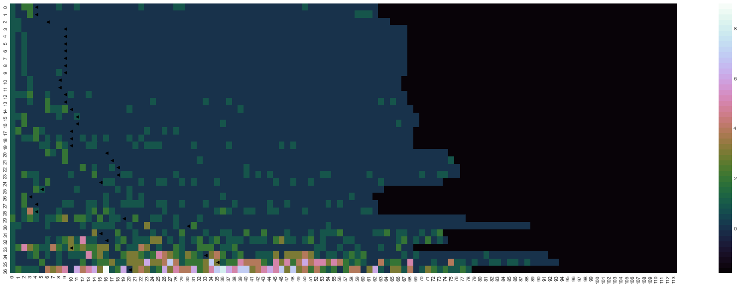

0. scodel, 1. overholser, 2. foenander, 3. gratiaen, 4. windells, 5. cassady, 6. kains, 7. kutak, 8. vonrhode, 9. wehrwein, 10. pelzel, 11. colcord, 12. liepmann, 13. schnepp, 14. dymond, 15. selekman, 16. ducoff, 17. hornseth, 18. orlansky, 19. benoitsmullyan, 20. bienstock, 21. waibel, 22. duncker, 23. gamio, 24. wecter, 25. powelson, 26. gloster, 27. blaustein, 28. bascom, 29. mangus, 30. mcclenahan, 31. fortune, 32. whetten, 33. ohlin, 34. mowrer, 35. terman, 36. roethlisberger

## 1960 – 1969

7388 total

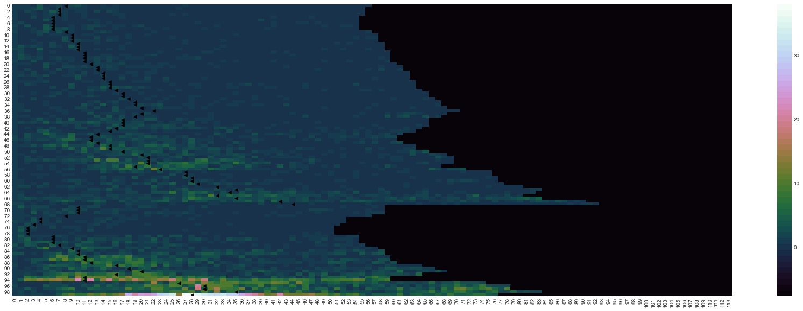

0. hajda, 1. cowhig, 2. fellin, 3. fanfani, 4. pepitone, 5. newfield, 6. welford, 7. wahlke, 8. videbeck, 9. fenchel, 10. hoos, 11. glanzer, 12. silvert, 13. wearmouth, 14. wessen, 15. larrabee, 16. rostovtzeff, 17. spectorsky, 18. mccleery, 19. winterbottom, 20. omari, 21. nottingham, 22. sprott, 23. viteles, 24. greenblum, 25. massarik, 26. hetzler, 27. montague, 28. marvick, 29. frenkelbrunswik, 30. hogbin, 31. honigmann, 32. kuder, 33. anshen, 34. benney, 35. simey, 36. truxal, 37. majumdar, 38. dai, 39. haer, 40. lionberger, 41. marcson, 42. congalton, 43. busia, 44. greenblatt, 45. copp, 46. fliegel, 47. miyamoto, 48. jaco, 49. hoselitz, 50. klapper, 51. ausubel, 52. tappan, 53. shevky, 54. manis, 55. zborowski, 56. koos, 57. opler, 58. panunzio, 59. saenger, 60. coutu, 61. goldhamer, 62. vonwiese, 63. northrop, 64. radcliffebrown, 65. dunham, 66. brunner, 67. thurstone, 68. spykman, 69. burling, 70. mcelrath, 71. bredemeier, 72. coolidge, 73. gutkind, 74. altus, 75. laskin, 76. shaycoft, 77. broadus, 78. pfeil, 79. gebhard, 80. bastide, 81. hoebel, 82. erasmus, 83. dinitz, 84. konig, 85. mccord, 86. presthus, 87. burchinal, 88. marris, 89. menzel, 90. belknap, 91. hovland, 92. reissman, 93. cumming, 94. cloward, 95. clinard, 96. kluckhohn, 97. redfield, 98. loomis, 99. hollingshead

## 1970 – 1979

30594 total

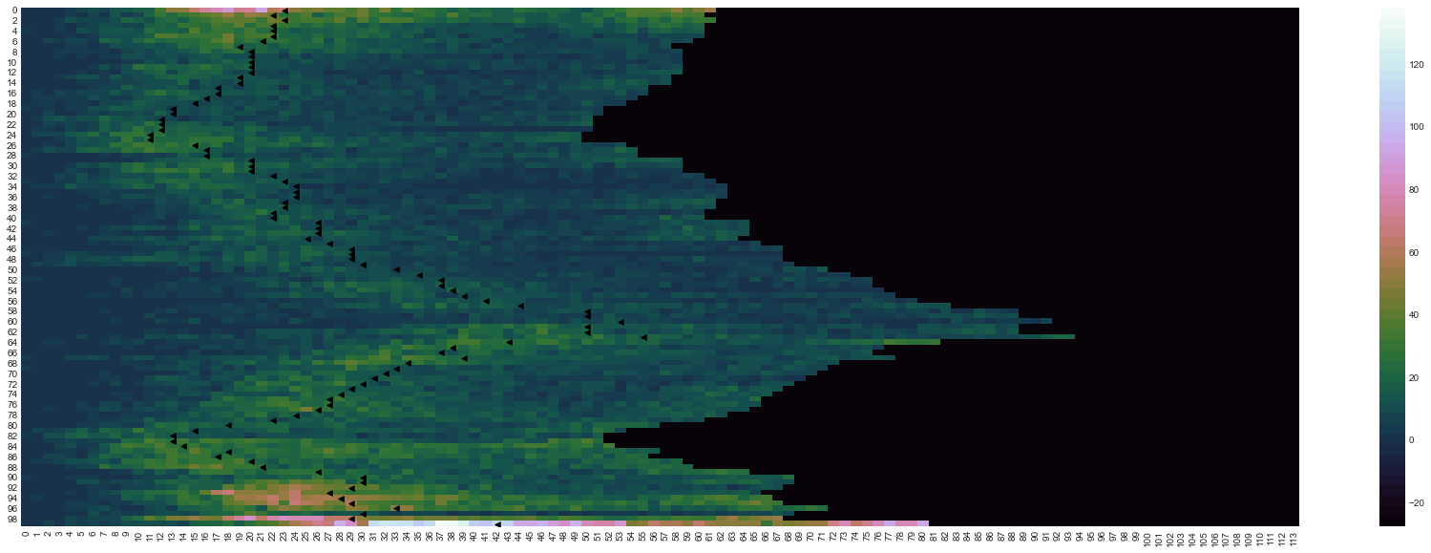

0. blalock, 1. kuhn, 2. coser, 3. gibbs, 4. wilensky, 5. glock, 6. dahrendorf, 7. blauner, 8. mechanic, 9. heer, 10. skolnick, 11. demerath, 12. easton, 13. banfield, 14. runciman, 15. luckmann, 16. matza, 17. alford, 18. rex, 19. sudnow, 20. laslett, 21. liebow, 22. chambliss, 23. scanzoni, 24. heise, 25. parkin, 26. cicourel, 27. hodge, 28. moskos, 29. olsen, 30. blood, 31. rainwater, 32. litwak, 33. srole, 34. kahl, 35. bott, 36. herberg, 37. horton, 38. ehrlich, 39. cutright, 40. lukacs, 41. cartwright, 42. mcclelland, 43. galbraith, 44. seeman, 45. sussman, 46. shibutani, 47. bogue, 48. riesman, 49. bales, 50. greer, 51. middleton, 52. fromm, 53. winch, 54. komarovsky, 55. gerth, 56. tannenbaum, 57. newcomb, 58. lynd, 59. landis, 60. ogburn, 61. kornhauser, 62. stouffer, 63. sorokin, 64. mannheim, 65. hawley, 66. lemert, 67. myrdal, 68. bendix, 69. selznick, 70. yinger, 71. caplow, 72. inkeles, 73. rokeach, 74. nye, 75. nisbet, 76. siegel, 77. janowitz, 78. gusfield, 79. glazer, 80. ryder, 81. scheff, 82. moynihan, 83. treiman, 84. jencks, 85. stinchcombe, 86. greeley, 87. smelser, 88. etzioni, 89. eisenstadt, 90. shils, 91. hyman, 92. reiss, 93. lenski, 94. gouldner, 95. goode, 96. homans, 97. berelson, 98. lipset, 99. parsons

39368 total

## 1980 – 1989

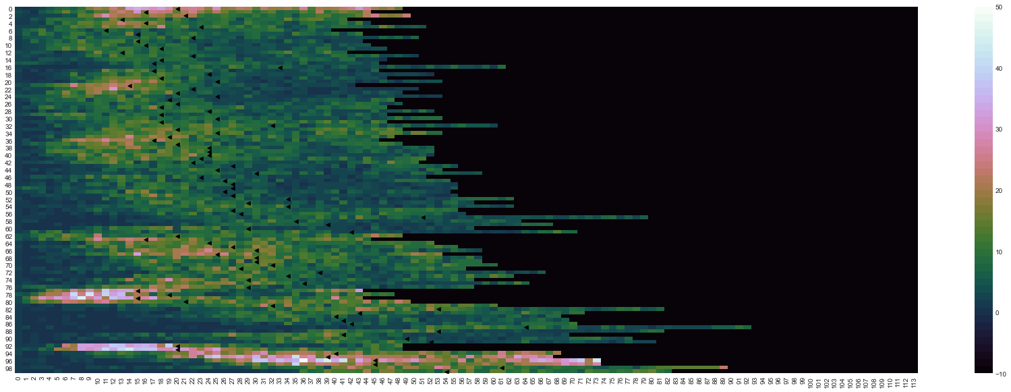

0. joreskog, 1. offe, 2. bishop, 3. verbrugge, 4. bluestone, 5. bradburn, 6. bainbridge, 7. aronowitz, 8. kohlberg, 9. frisbie, 10. hibbs, 11. hindess, 12. unger, 13. hymes, 14. gorsuch, 15. oneill, 16. coombs, 17. modell, 18. lopata, 19. fienberg, 20. quinney, 21. spanier, 22. kerlinger, 23. miliband, 24. rodman, 25. hope, 26. paige, 27. boserup, 28. zurcher, 29. illich, 30. burch, 31. liska, 32. wrong, 33. lasch, 34. tittle, 35. doeringer, 36. hindelang, 37. spilerman, 38. zeitlin, 39. hadden, 40. schur, 41. blumberg, 42. chomsky, 43. breton, 44. spitzer, 45. antonovsky, 46. dye, 47. masters, 48. palmore, 49. hagen, 50. vandenberghe, 51. fuguitt, 52. hempel, 53. otto, 54. boulding, 55. aries, 56. driver, 57. cressey, 58. lindblom, 59. shepard, 60. goldberger, 61. centers, 62. gurr, 63. knoke, 64. oberschall, 65. rapoport, 66. dohrenwend, 67. cain, 68. coale, 69. lyman, 70. dumont, 71. goody, 72. kish, 73. rotter, 74. wolfgang, 75. westoff, 76. gurin, 77. hanushek, 78. nie, 79. braverman, 80. land, 81. levinson, 82. murdock, 83. hammond, 84. lowenthal, 85. neugarten, 86. lester, 87. child, 88. lenin, 89. form, 90. cantril, 91. taeuber, 92. poulantzas, 93. featherman, 94. freedman, 95. rossi, 96. hauser, 97. mueller, 98. wirth, 99. schuman

34425 total

## 1990 – 1999

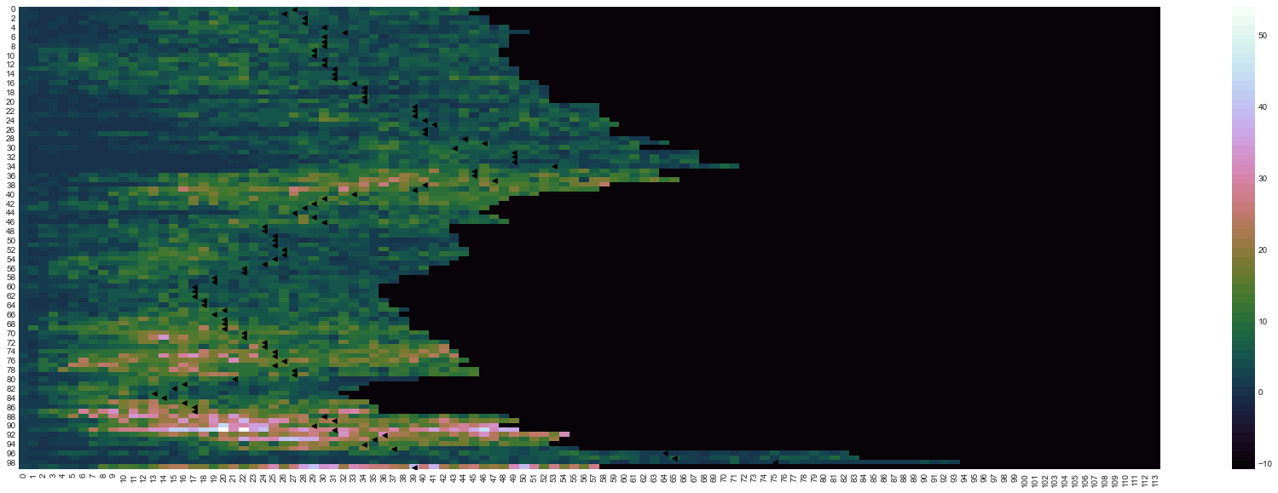

0. kornai, 1. scully, 2. neter, 3. abercrombie, 4. cleary, 5. liebman, 6. crandall, 7. fararo, 8. mouzelis, 9. kreps, 10. staples, 11. bahr, 12. nelsen, 13. aldous, 14. sudman, 15. wiley, 16. box, 17. friedan, 18. silberman, 19. press, 20. odonnell, 21. pollak, 22. abrahamson, 23. dore, 24. london, 25. coulter, 26. ashworth, 27. willmott, 28. keyfitz, 29. clegg, 30. dornbusch, 31. mott, 32. cantor, 33. roemer, 34. rollins, 35. obrien, 36. maccoby, 37. straus, 38. sweet, 39. perrow, 40. labov, 41. blumstein, 42. rothman, 43. summers, 44. herrnstein, 45. handler, 46. cockburn, 47. rosaldo, 48. polachek, 49. mehan, 50. delacroix, 51. chafetz, 52. roos, 53. eisenstein, 54. trivers, 55. gelles, 56. bane, 57. spenner, 58. iso-ahola, 59. deem, 60. felmlee, 61. pollert, 62. fossett, 63. lennon, 64. grossberg, 65. szelenyi, 66. skvoretz, 67. spitze, 68. parcel, 69. clogg, 70. marini, 71. maddala, 72. chodorow, 73. kluegel, 74. oakley, 75. piore, 76. roof, 77. stolzenberg, 78. thurow, 79. pleck, 80. csikszentmihaly.m, 81. menaghan, 82. coverman, 83. markovsky, 84. demo, 85. lyotard, 86. yamaguchi, 87. gilligan, 88. gove, 89. hannan, 90. aldrich, 91. kanter, 92. farley, 93. berk, 94. pahl, 95. tuma, 96. dollard, 97. hiller, 98. herskovits, 99. lieberson

## 2000 – 2010

36105 total

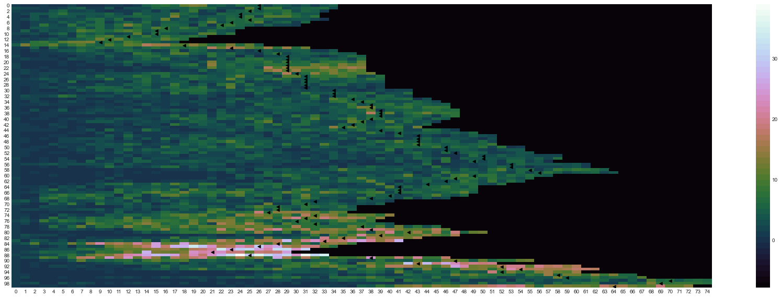

0. spain, 1. boden, 2. beatty, 3. miethe, 4. rook, 5. billy, 6. crouter, 7. samdahl, 8. beggs, 9. aseltine, 10. ascione, 11. mauthner, 12. fuligni, 13. chantala, 14. astone, 15. lehrer, 16. hammitt, 17. reinharz, 18. tickamyer, 19. steelman, 20. sabo, 21. arluke, 22. coffey, 23. mcdonough, 24. lyson, 25. isoahola, 26. waldron, 27. cernkovich, 28. shelby, 29. delphy, 30. spender, 31. wagenaar, 32. picou, 33. hedges, 34. acheson, 35. kotler, 36. rosenstone, 37. mcallister, 38. donaldson, 39. dickens, 40. nelkin, 41. poster, 42. knights, 43. mchale, 44. hanks, 45. mackay, 46. himmelfarb, 47. blaug, 48. spilka, 49. kain, 50. kagan, 51. psathas, 52. geis, 53. rieff, 54. grimshaw, 55. beattie, 56. schulze, 57. agger, 58. pollard, 59. munch, 60. donahue, 61. hecht, 62. crick, 63. gorz, 64. rappaport, 65. wrigley, 66. jessor, 67. mulkay, 68. fogel, 69. ewen, 70. bosk, 71. hagenaars, 72. glassner, 73. heelas, 74. ogbu, 75. hebdige, 76. corcoran, 77. maines, 78. hirst, 79. thorne, 80. rutter, 81. seale, 82. mosse, 83. gubrium, 84. tienda, 85. bryk, 86. shilling, 87. bordo, 88. featherstone, 89. kasarda, 90. astin, 91. kay, 92. hanson, 93. winter, 94. haines, 95. vandijk, 96. titmuss, 97. johnstone, 98. mccormick, 99. maynard

## 2010 – 2018

341957 total

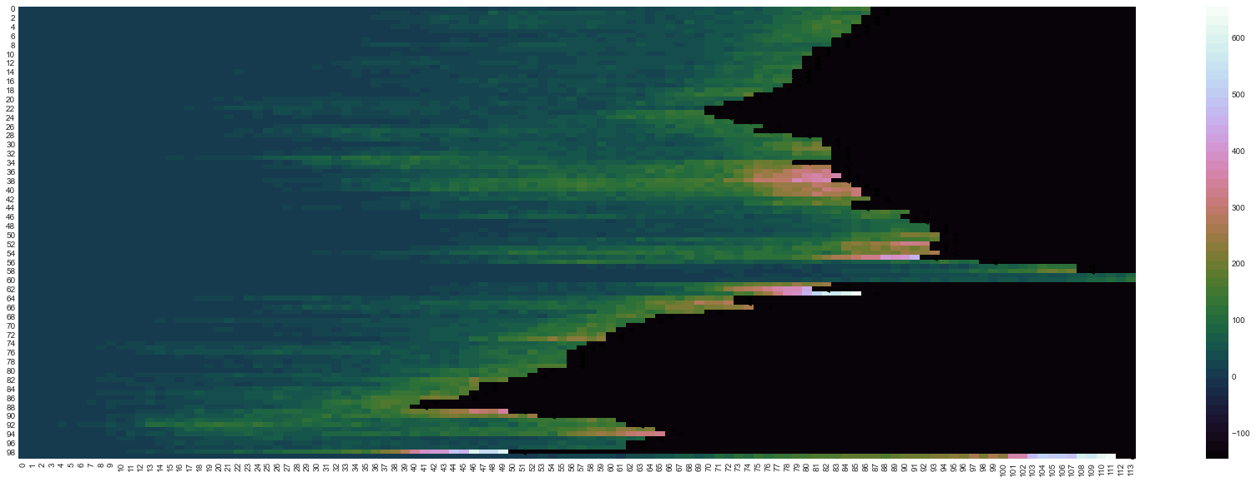

0. green, 1. edwards, 2. robinson, 3. hill, 4. harris, 5. allen, 6. atkinson, 7. peterson, 8. douglas, 9. cook, 10. baker, 11. nelson, 12. blumer, 13. morris, 14. hunter, 15. schneider, 16. fox, 17. friedman, 18. jenkins, 19. bennett, 20. rogers, 21. simon, 22. rosenberg, 23. schwartz, 24. strauss, 25. west, 26. erikson, 27. gordon, 28. mills, 29. katz, 30. alexander, 31. lewis, 32. bell, 33. merton, 34. campbell, 35. miller, 36. hall, 37. brown, 38. cohen, 39. wilson, 40. becker, 41. taylor, 42. thompson, 43. jackson, 44. hughes, 45. young, 46. marx, 47. shaw, 48. marshall, 49. walker, 50. king, 51. white, 52. lee, 53. turner, 54. davis, 55. anderson, 56. duncan, 57. adams, 58. butler, 59. james, 60. ross, 61. beck, 62. de, 63. van, 64. rose, 65. collins, 66. scott, 67. meyer, 68. harvey, 69. glaser, 70. allison, 71. sampson, 72. connell, 73. putnam, 74. gamson, 75. stark, 76. habermas, 77. jacobs, 78. snow, 79. evans, 80. bauman, 81. tilly, 82. portes, 83. kim, 84. hochschild, 85. granovetter, 86. massey, 87. dimaggio, 88. latour, 89. foucault, 90. giddens, 91. berger, 92. blau, 93. coleman, 94. goffman, 95. goodman, 96. garfinkel, 97. geertz, 98. bourdieu, 99. smith



